Page | 0

Grand Valley Fire Protection District
2022

STRATEGIC PLAN

“Strategic planning will help you fully uncover your available options, set priorities for them, and define the methods to achieve them."

-Robert J Mckain

Table of Contents

Introduction 1
Strategic Plan 6
Financial Overview 14
District Review 18
Population and Demographic Information 25
Community Survey Results 29
Employee Survey Results 57
Previous Strategic Plan 64

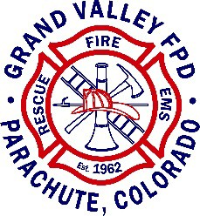

Introduction

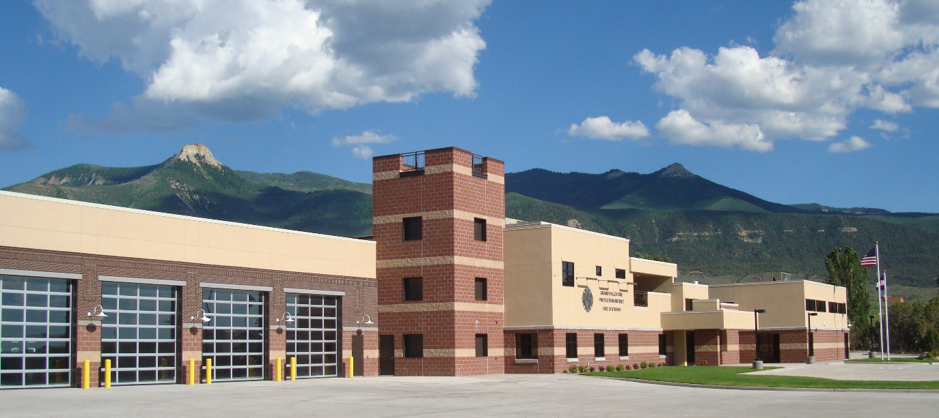

Fire Districts across Colorado are facing an increased challenge in meeting rising service levels in constrained fiscal environments. The Grand Valley Fire Protection District (“the District”) is tasked with the provision of quality emergency fire and medical services, public education, and fire prevention programs. These services are delivered by a combination of paid and volunteer staff. A changing economic environment drives the need for forward- thinking planning to provide a resilient foundation for the District’s future.
The Grand Valley Fire Department was formed in February of 1962 and became the Grand Valley Fire Protection District in April of 1963. Oversight of the District is provided by an elected Board of Directors (five members) and with the leadership of the Fire Chief. The District service area is approximately 320 square miles in Garfield County and .75 square miles in Mesa County (Housetop Mountain Estates). There are 2,663 registered voters in the District. The 2022 adopted operating budget is $5,010,918. The total assessed valuation is $597,475,680 with a mill levy of 6.233.

The District responded to 1063 calls for service in 2021; those calls were predominately rescue and emergency medical service calls. Other types of calls are included in the chart below.

INCIDENT TYPE BREAKDOWN

MAJOR INCIDENT TYPE |  | # INCIDENTS | % of TOTAL
Fires |  | 53 | 4.99%
Rescue & Emergency Medical Service |  | 727 | 68.39%
Hazardous Condition (No Fire) |  | 32 | 3.01%
Service Call |  | 115 | 10.82%
Good Intent Call |  | 99 | 9.31%
False Alarm & False Call |  | 36 | 3.39%
Special Incident Type |  | 1 | 0.09%
 | TOTAL | 1063 | 100%

Source: Grand Valley Fire Protection District

The core operational elements of the District include:

- 46 personnel
  - 16 full-time employees
  - 19 part-time employees
  - 11 volunteers
  - 5 Auxiliary members
- Stations:
  - Station 1, Battlement Mesa, 33,611 sq.ft.
  - Station 2, Parachute, 3,263 sq. ft.
  - Station 3, Rulison, 4,000 sq.ft.
  - Parachute Training Center, five acres with 300’X 300’ driver training pad
- Rolling stock equipment totals approximately 39 pieces. Several pieces of equipment have been reallocated to secondary use and with few pieces being disposed of or sold. The primary equipment includes:
  - 2 Engines
  - 1 Ladder/Platform
  - 1 Ladder
  - 2 Tenders
  - 3 Brush Trucks
  - 4 Ambulances
  - 4 Utility Trucks
  - Other equipment includes ATVs, trailers, snowmobiles, etc.

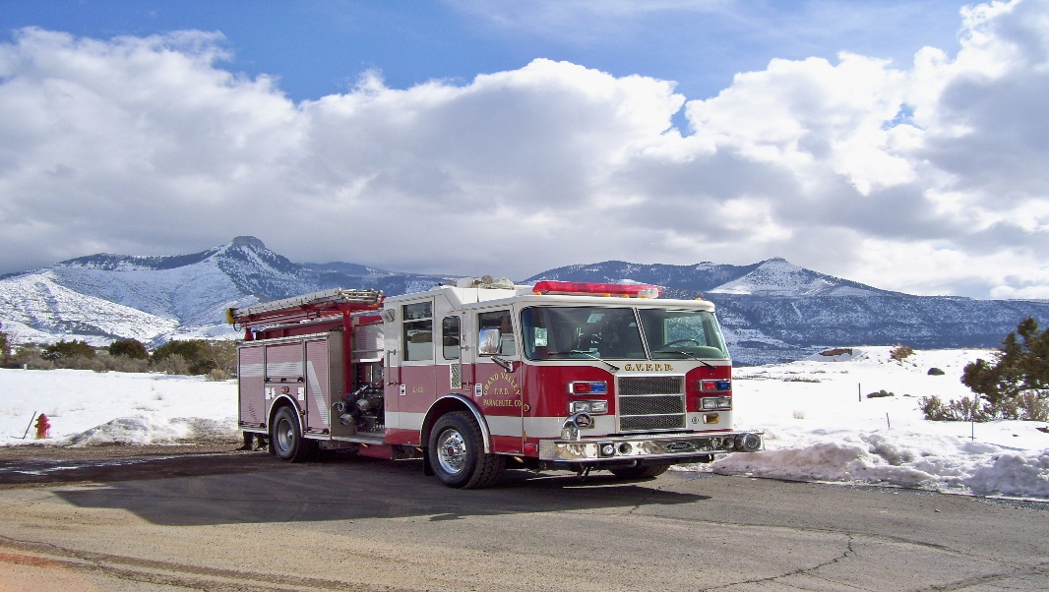

Strategic planning is an organizational management activity that is used to set priorities, focus energy and resources, strengthen operations, ensure that employees and other stakeholders are working toward common goals, establish agreement around intended outcomes/results, and assess and adjust the organization's direction in response to a changing environment. It is a disciplined effort that produces fundamental decisions and actions that shape and guide what an organization is, who it serves, what it does, and why it does it, with a focus on the future.¹ Effective strategic planning articulates not only where an organization is going and the actions needed to make progress, but also how it will know if it is successful.
Intrinsic to strategic planning is the concept of strategic thought and action. In order to develop a forward-thinking document that guides an organization’s decision making and resource allocations, it is essential to ensure a well-rounded, comprehensive, and deliberate approach. As a public organization, the District’s Strategic Plan is best served if it reflects community values. To that end, several engagement tools were utilized throughout the process to gather input and data. Efforts included:
- Board review
- Staff focus group
- Partner/Agency focus group
- Community focus groups input
- Community input
- Employee survey
- Update of previous strategic plans
A summary of this information is provided later in the report. The resulting document is a culmination of the discussions and input received throughout the process as well as the direct guidance provided by the Board, staff, and citizen input.

¹ John M. Bryson, Strategic Planning for Public and Nonprofit Organizations: A Guide to Strengthening and Sustaining Organizational Achievement (San Francisco: Jossey-Bass, 1995), x.

Strategic Plan

The District identified the following three core strategic initiatives to focus and guide future decision making and resource allocations. These core strategic initiatives include community service, fiscal sustainability and organizational excellence and are discussed in detail below. While each area has specific steps to achieve positive outcomes, they are interwoven and must be integrated with the other core areas in order to ensure successful implementation. Strategic statements, goals, and tactics accompany each of these core efforts.
An organizational mission statement, values statement, and Code of Ethics are some of the key documents that define an organization’s culture. These should accompany a strategic plan to help orient staff, Board, and citizens toward a desired outcome. The following were previously developed by the District and remain in place.

Mission Statement:

We, the members of the Grand Valley Fire Protection District, dedicate our efforts to the protection of the lives, property and environment of the citizens of, and visitors to, the Grand Valley Fire Protection District.

Values:

External

- We recognize that the citizens of, and visitors to, the Grand Valley Fire Protection District are the reason for our existence.
- We value the faith and trust of the community and will continually work to deserve that confidence through our attitude, conduct and accomplishments.
- We will actively participate in community life and, by example, serve as leaders and role models.
Internal:

- We value our personnel as dedicated and compassionate volunteers, who strive to meet the changing needs of our community.
- We will strive for excellence in everything we do.
- We will provide professional and courteous service at all times.
- We will always remain committed to training, education and opportunities for advancement and professional development for the members of the Grand Valley Fire Protection District.
- Unity and teamwork are stressed as being to our mutual advantage as individuals and as an organization.
- We will strive to maintain an environment open to change.

Code of Ethics:

- To strive to recognize the importance of and to honor my profession.
- To conduct my personal and official life so as to inspire public confidence.
- To prevent personal gain or profit from being the object of my endeavor.
- To judge my fellow firefighters by standards that I myself hold, and to never jeopardize the safety of my fellow firefighters.
- To regard it as my duty to possess adequate knowledge to perform my job and avail myself of opportunities to learn more about my profession.
- To avoid alliances with personnel or businesses whose goals are inconsistent with the performance of a firefighter.
- To never claim unjustly qualifications I do not possess.
- To share publicity equally with fellow firefighters whether favorable or unfavorable.
- To pledge loyalty to my supervisors, fellow firefighters and to the organization I represent.
- To bear constantly in mind that the truth is to be sought before a cause is made, so that the stature of the Grand Valley Fire Protection District firefighters can be enhanced rather than tarnished.
- To be ever conscious that public service is part of the public trust and all actions taken shall be towards the benefit of the Grand Valley Fire Protection District and the public we serve.
- To not accept gifts, money or favors from anyone other than the District having authority. The action of accepting gifts from individuals may be perceived as an attempt to influence the decisions of the District.
- To never disclose confidential information either acquired or that has been made available, or to use such information for speculation or personal gain.
- To never use District equipment or property to gain an advantage or for personal gain.
- To always perform all duties safely, earnestly, economically and efficiently.
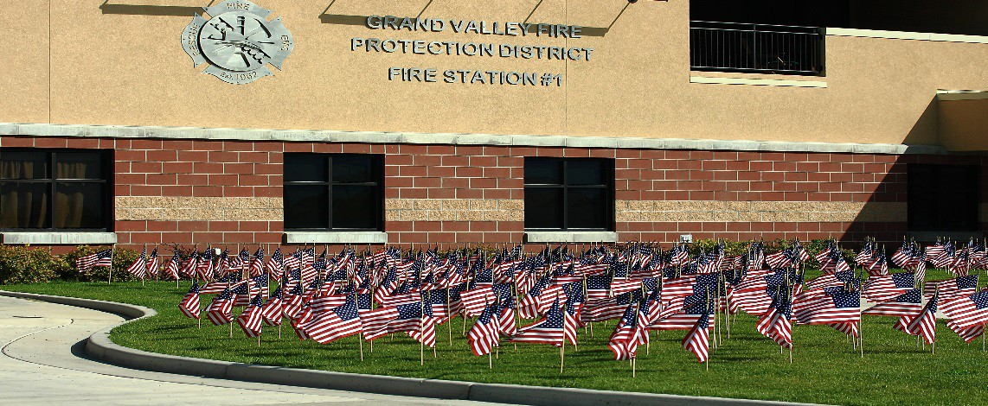

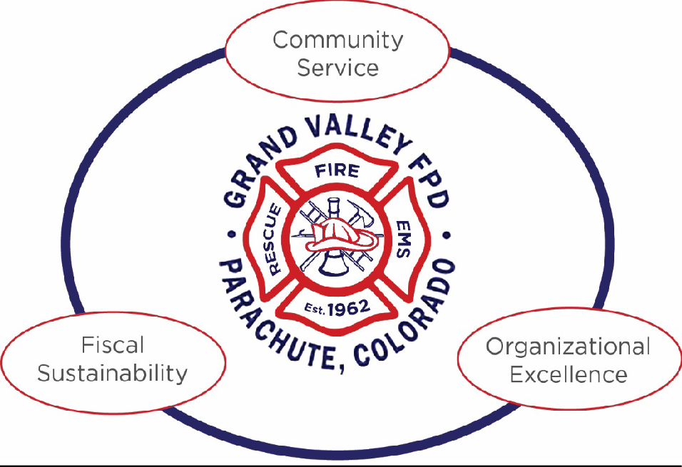

Strategic Statements

Community Service

Deliver valued, efficient, and effective emergency medical, fire, public education, and prevention services throughout our District that promotes the safety and health of our citizens and visitors, honors our community values, and supports our partner agencies.

Fiscal Sustainability

Strengthen our financial position with sound financial planning and responsible use of District funds in anticipation of a changing economy to ensure the continued delivery of valued emergency services to our community.

Organizational Excellence

Provide a positive and productive work environment that results in well-trained, well- equipped paid and volunteer staff and promotes the District as the employer of choice.

Community Service

Strategic Statement – Deliver valued, efficient, and effective emergency medical, fire, public education, and prevention services throughout our District that promote the safety and health of our citizens and visitors, honors our community values, and supports our partner agencies.

Strategic Goals:
- Continue community outreach program to build awareness of existing programs and promote good neighbor citizenship
- Maintain current ISO rating
- Provide valued prevention education programs
- Strengthen community partnerships and collective outcomes

Strategic Tactics:

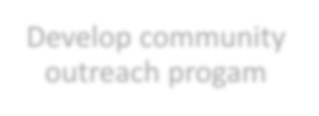


Continue community outreach program
- Identify outreach goals
- Continue comprehensive outreach plan w/appropriate strategies and tools
- Continue social media policy
- Provide outreach training for designated staff





Maintain ISO rating

- Ensure maintenance of required recordkeeping
- Inspect and correct equipment deficiencies
- Conduct structure fire training with staff and volunteers
- Complete pre-plans of all commercial buildings
- Maintain commercial building inspections annually
- Maintain current fire codes and enforcement


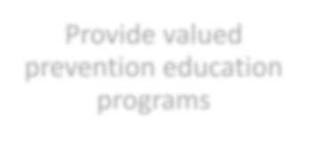


Provide valued prevention education programs
- Evaluate & update existing programs
- Conduct satisfaction surveys
- Provide "Did You Know?" prevention campaign directed to engage citizens
- Evaluate alternative learning techniques
- Create evaluation benchmarks

Strengthen community partnerships

- Identify key community partners

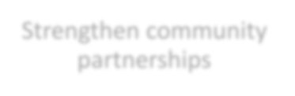

- Hold partnership meetings with Board as needed
- Identify common issues and goals
- Seek opportunities to share resources and training programs
- Engage partners to complete community emergency evacuation plan

Fiscal Sustainability

Strategic Statement – Strengthen our financial position with sound financial planning and responsible use of District funds in anticipation of a changing economy to ensure the continued delivery of valued emergency services to our community.

Strategic Goals:

  - Continue debt-free financial operations
  - Ensure prudent financial investment in infrastructure and equipment
  - Develop diversified revenue base
  - Establish long-term financial planning practices

Strategic Targets:

Continue debt-free financial operations
- Meet reserve target

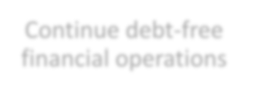

- Evaluate labor costs
- Analyze cost-effectiveness of staff components
- Evaluate cost sharing with other agencies


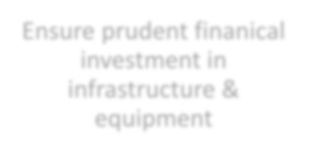


Ensure prudent financial investment in infrastructure & equipment
- Conduct systematic maintenance, replacement, and acquisition of equipment (life cycle, primary use, secondary use, replacement)
- Evaluate need & purpose of equipment acquisitions
- Pursue land acquisition for infrastructure investment
- Ensure appropriate asset management schedule (building maintenance, etc.)


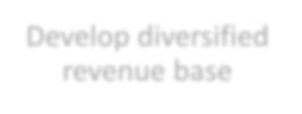


Develop diversified revenue base
- Evaluate & promote subscription program
- Evaluate wildland fire deployment revenues
- Evaluate building permit/inspection fee program
- Continue to evaluate special service event fee
- Identify strategic grant opportunities


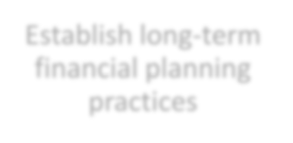


Establish long-term financial planning practices

- Provide projection of key revenues
- Provide five-year projection of key expenditure
- Identify and monitor key economic indicators
- Continue to evaluate mill levy analysis

Organizational Excellence

Strategic Statement – Provide a positive and productive work environment that results in well-trained and well-equipped paid and volunteer staff and promotes the District as the employer of choice.

Strategic Goals:

  - Develop performance program
  - Create a “contribute, participate, and listen” work environment
  - Ensure appropriate staff capabilities and qualifications for service delivery
  - Promote engaged and active relationships with staff and leadership
  - Actively recruit volunteer membership

Strategic Tactics:

Develop performance program
- Review & update job descriptions

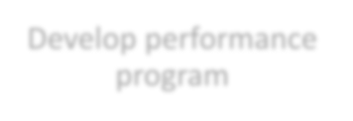

- Identify key performance expectations & define accountability standards
- Provide supervisory and employee training on expectations
- Provide routine performance guidance
- Conduct annual performance review for all levels of staff

Create "contribute, participate & listen" culture
  - Develop internal communication plan and assign responsibility

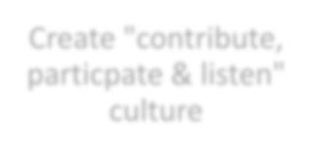

  - Schedule quarterly small group roundtables with staff and Chief
  - Provide training for personal development (i.e., listening/communication skills)
  - Identify & implement a feedback mechanism for staff & volunteers regarding department operations

Ensure appropriate staff capabilities & qualifications

- Determine level of service standards
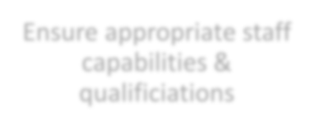

- Identify necessary qualifications per function/position
- Identify desired/necessary capabilities per function/position
- Identify training program including expectations and timeline
- Conduct wage & benefit survey
- Review qualifications/capability requirements


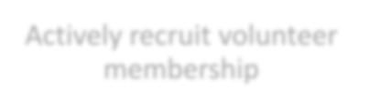


Actively recruit volunteer membership
- Establish volunteer need/target for department
- Establish phased recruitment goals
- Define recruitment tools and assign responsibilities
- Partner with other agencies for recruitment events
- Provide robust volunteer orientation program
- Identify key benchmark indicators for annual review

Financial Overview

The District, similar to other public entities in the region, has experienced the cycle of natural energy development that brings both service demands, increased revenues, and a fluctuating economy. Garfield County has identified this as a significant issue in all budget discussions. Garfield County noted in years 2014, 72.9 percent of total property tax assessed values were accounted for by oil and gas industry. In 2018, this had dropped to 55 percent.

The Grand Valley Fire Protection District has seen significant fluctuation in property tax assessed values as a result of oil and gas industry activity. In 2014, 93.9 percent with a total dollar amount of $1,144,024,720. In 2018, 89.1 percent with a total dollar amount of $707,362,010. Then in 2020, 85.5 percent with a total dollar amount of $597,115,970.

The rate of decline for oil and gas revenues and its duration is unknown, as well as the potential rate of recovery for oil and gas production to return to Garfield County.

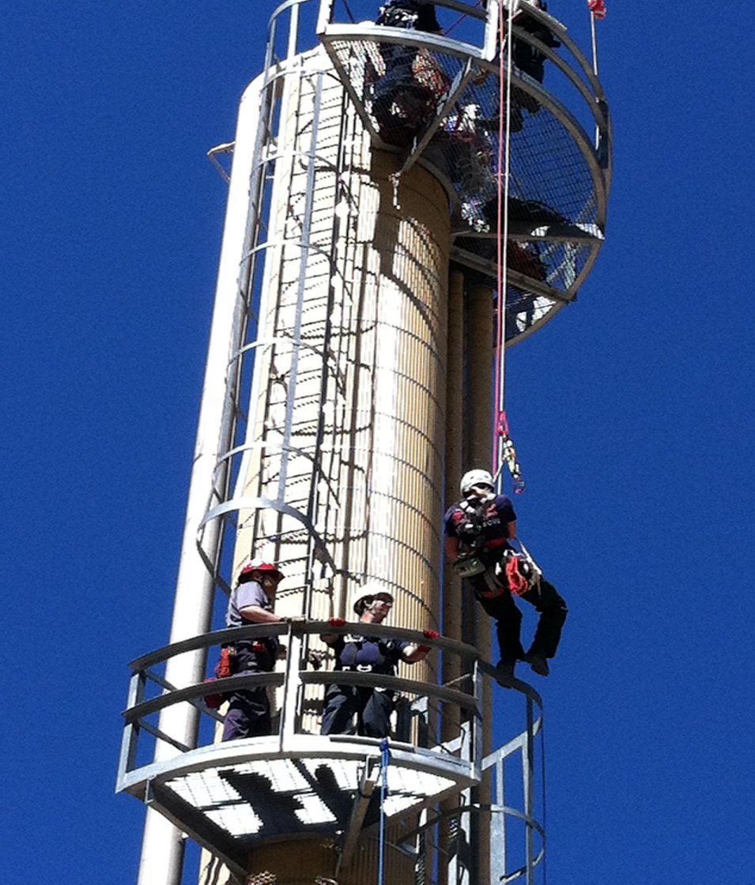

The District has worked diligently to develop its infrastructure and equipment, as well as to increase patient care with trained paramedics. However, it is anticipated that the primary financial revenue stream for the District--assessed valuation from the development and production of oil and gas--is facing a significant reduction in the coming years. The following is a breakdown of assessment categories:

Abstract of Assessment Breakdown

Type | Percent
Vacant Land | 1.28%
Residential Property | 5.37%
Commercial Property | 3.41%
Industrial Property | 1.18%
Agricultural Property | 0.29%
Natural Resources | 0.01%
Producing Mines (Oil Shale) | 0.04%
Oil & Gas Property | 85.47%
State Assessed Property | 2.96%
Source: Garfield County

Since 2008, Garfield County has experienced a consistent decline in natural gas exploration and production; it is anticipated that the District will experience a decline in oil and gas revenues during the next valuation period. To that end, the District has undertaken steps in anticipation of this financial shift by increasing its reserve fund to $6,529,240 to offset the impact. The District’s target reserve goal is $8,986,982 (based on 2021 budget) or two years of operational expenditures. The District has taken prudent measures to address decline.

It is recommended that additional financial steps be taken, including:
  - Staffing Component Analysis – an evaluation of the balance of paid full-time and part-time staff and volunteer ratios.
  - Alternative Revenue Analysis – an evaluation of potential revenue sources including special event fees, plan review/building inspection fees, subscription fees, grant revenues, and wildland fire deployment fees.
  - Continue review of Level of Service – an assessment of levels of service, specifically cost benefit of paramedic level service.
  - Cost-Sharing Analysis –continue cost-sharing opportunities with partner agencies in training, and continue to evaluate opportunities in vehicle, and building maintenance.
  - Asset Inventory & Replacement Schedule – a review of existing assets has been completed to identify assets that can be disposed of or sold to reduce maintenance expense to the District for items not necessary or essential for service delivery.
The District has recently undertaken a salary survey and has implemented a performance- based compensation plan. The following items are recommended for consideration:
  - Limitation of compensation increases over the next three years.
  - Evaluation of positions vacant due to normal attrition to determine need to rehire or supplement with volunteer force.
This revenue impact combined with the fiscal requirements of the Colorado Taxpayer’s Bill of Rights (Colorado Constitution, Article X, Section 20) has set the stage for the District to develop a strategic plan to guide its decision making into the future. Understanding potential future financial impacts that the District will be facing allows for a thoughtful and forward-thinking response and management to a changing environment.

District Review of Past, Strategic Plans, and Future Forecast

Grand Valley Fire Protection District Board

Expectations

Expectations of a Strategic Plan are:

- Roadmap for the future
- Identify terrain/obstacles
- Provide a rallying point
- Establish goals and time frames
- Identify realistic solutions

Past Strategic Plans In Review

What Worked Well?

- Reporting system
- Training Program
  - Number of paramedics
  - Qualifications and certifications
  - Number of training opportunities
- Finances – over-estimating and under spending
- Community satisfaction is good as the mill levy increase was a vote of approval
- Community service
- High presence in community
- Top-notch facilities and equipment
- Top-notch personnel
- Low ISO rating
- Reserve is greater than 70% of goal and growing each year
- Ability to work together
- High visibility
- Engaged in community conversations
- Response time/medical
- Improvement on rules/regulations, compensation
- Increased input from staff
- Personnel evaluation system
- Summer wildland program
- Subscription program
- First aid/CPR/fire extinguishing training
- Climbing wall
- Land at Parachute Station was purchased
- Third party medical collections and efficiency
- P/T shift coverage was an issue in last Plan – unfilled shifts improved from 35 to 28%
- Internal communication between staff and administration
What Didn’t Work Well?

- Economic downturn
- Change in demographic
- Mechanical issues/ambulances
- No increase in volunteer program
- Some citizens don’t call 911 when they should
- Public education – medical – bill/$
- Subscription program needs to be advertised
- Language barrier
- Apathetic community
- Reduction in community income levels – entitlement
- Change in expectations
- Change in long-term residency
  - Change in retention of volunteers
- Limited pool of resources
- Communication
  - Newsletter

Strengths, Weaknesses, Opportunities and Threats Analysis

Internal Strengths

- Members/age and training
  - (Members) Employees and volunteers
- Facilities/Equipment
- Board Members
- Strong financial position/planning
- Community involvement
- District experience and cross training is increasing
- Willingness to contribute, participate and listen
- Training program
- Diversity – age, gender, education
  - Where they live vs. other places
- Better documentation all around
- NO DEBT!
- Equipment maintenance
- Apparatus
- Wages and benefits
- 48/96 schedule
- Low turnover rate
- Community perception
- Moderate mill levy
- Reporting system CQI (liability reduction)
- Interagency coordination
- Review all inspections of buildings/fire suppression plan in-house at no charge
- Staffing improvements (PTE coverage)
- EVAC Plan created and maintained
- Communication improvements
- Successional planning improvement
- Interaction w/partners
- Emergency response plan
Internal Weaknesses

- Sustaining the size and scope of the District
- Recognizing declining revenue
- Service needs to be tailored to our District
- Succession plan implementation
- Continued improvements in communication
- Public outreach
- Vol/PT staffing/ownership
- Duplication of services
- Land ownership
External Opportunities

- Out-of-district deployments
- Volunteer recruitment (high school and community)
- Federal, State and County oil and gas local grant programs
- Auto aid
- Better community relations/communication
- Parachute training use and improvements
  - Pending lease agent
- Cooperation with CMC for FFT/EMS classes at Station 31
- Center for Excellence – wildfire management
- Patient/customer follow-up/survey
- Community training/Educate by demographic
- Fire-wise community
- Community paramedic/Interfacility Transfers
- Coop with Colorado River Fire Rescue and other Districts for training
- Coop with County agencies and community partners on teams, i.e., HAZ-MAT
- Information sharing with dispatch – Mobile Data Terminals
- Providing training for businesses
- Cost share vehicle maintenance with other agencies
External Threats

- Grand River Hospital – increased patients
- Increased calls for emergency transport
- Over lapping calls for service
- Economic development
  - Events increase transient population with increased calls
  - Bike trails/highway
  - Lakes
  - Proposed event center
- Economy decreases
- Volunteer competition
- Budget – not diversified revenue
- Stability of key partner – Town of Parachute and Battlement Mesa
- Changing demographic of population
- Affordable Care Act
- Isolation
- Reduced budgets – partners
- Marijuana industry and related health and social problems
- Remote calls for service
- Un-incorporation of Battlement Mesa has disadvantages
- Improve radio programing with County dispatch system
- Being all things to all people
- High-risk, low-frequency events
- Public relations
- Proposed large residential development

Strategic Themes

Community Service

Short-Term

- Continue to note public feedback on services
- Volunteer recruitment
- Good neighbor citizenship
- Second and third calls

Mid-Term

- Community outreach
- Fire-wise community/education
- Fire inspection/building inspection program
- Bilingual staff (Spanish)
- Plan review
- Advertising current programs Long-Term
- Declining revenue
- Maintain low ISO rating (ISO rating scale is based on 1-10, 1 being the best possible ISO rating.)

Undetermined Term
- Community program
- GVFPD subscription service
- Community partnerships
- Maintain or exceed medical services level

Organizational Excellence

Short-Term

- Communications: contribute, participate, and listen
- Staffing capabilities and qualifications
  - Full-time vs. Part-time and volunteer requirements
- Shift coverage/staff levels
- Volunteer recruitment
- Accountability/performance evaluation
- New member orientation/training
- Second and third call staffing

Mid-Term

- Succession planning
- Interagency cooperation and coordination
- Active Board of Directors
Long-Term
- GREAT relationships between staff and leadership

Undetermined Term

- Well-trained staff
- Well-equipped staff (with personal protective equipment)
- Wages and benefits
- Limited pool of resources
- Realistic expectations
- Paramedic-level patient care
- Participative management supporting operations

Fiscal Sustainability

Short-Term

- Strong financial position/planning
- No debt
- Apparatus replacement schedule
- Land ownership
- Alternative revenue streams – Wildland deployments/FEMA response
- Vehicle and building maintenance
- Cost effectiveness of volunteers, part-time and full-time

Mid-Term
- Parachute Training Center
- Cost sharing w/other local governments/agencies
- Develop financial plans
- Billable services
- Grants
- Meet reserve target
- Continue to evaluate mill levy

Long-Term
- Economy decrease/increase
- Support community fiscal diversification

Undetermined Term

- District assessed valuation

Population and Demographic Information

Garfield County Population and Demographic Information

Garfield County is one of 64 counties in the state of Colorado, and is one of the largest at almost 3,000 square miles (almost 1.9 million acres). About 60% of Garfield County lands are federally owned:
- Bureau of Land Management (BLM) - 615,973 acres
- U.S. Forest Service (USFS) - 515,865 acres
- Bureau of Reclamation - 2,335 acres

The western portion of the County is a sparsely populated, high desert plateau, while the eastern portion includes the western foothills of the Colorado Rocky Mountains and most of the county’s 60,000 residents according to the 2018 U.S. Census. The District’s population is estimated at 6,200.

Population
Garfield County has five municipalities that stretch along the Colorado River and the I-70 corridor and one town, Carbondale, situated along the Roaring Fork River, whose economic fortunes are closely tied to those of Aspen and Snowmass Village. Rifle is the largest community according to April 01, 2020 Census.

Garfield County and the District’s population has experienced strong periods of growth dating back to 1890), in part due to mining and other industries.

Source: U.S. Census Bureau

Garfield County has experienced a steady increase in population since 1970. Population grew rapidly at 2.7% per year between 2004 and 2009 which was the result of a growing natural gas extraction industry, and also due to an ongoing but slower expansion of tourism, second home development, and regional services.

During the 2000’s there was also a significant in-migration of new workers and families, which fueled housing development, retail expansion, and rapid wage growth. At times during this period, Garfield County experienced shortages of labor and a rapidly appreciating housing market. Due to the national and local recession, population declined slightly between 2009 and 2011, but has been increasing since 2012 at rate of approximately 0.7% per year (and this increase is expected to continue).

Source: Colorado Department of Local Affairs

The State of Colorado Department of Local Affairs (DOLA) projects that population in Garfield County will increase steadily at 2.45% per year between 2015 and 2040 (Chart 1 and Table 1). DOLA projects that the rate of population growth will be even higher between 2021 and 2030, at 2.75% per year. Overall, the County is projected to experience a higher rate of population growth than the state as a whole.
The job growth is expected to increase steadily as well as the population, see Chart 2.

Chart 1

Garfield County Population Projections 2015 - 2040
120,000

100,000

80,000

60,000

40,000

20,000

0
Source: Colorado Department of Local Affairs

Table 1 – Population CAGR
Period | Garfield CO | State CO
2015-2020 | 2.45% | 1.72%
2021-2030 | 2.75% | 1.54%
2030-2040 | 2.15% | 1.15%
2015-2040 | 2.45% | 1.43%
Note: CAGR = compound annual growth rate

Chart 2
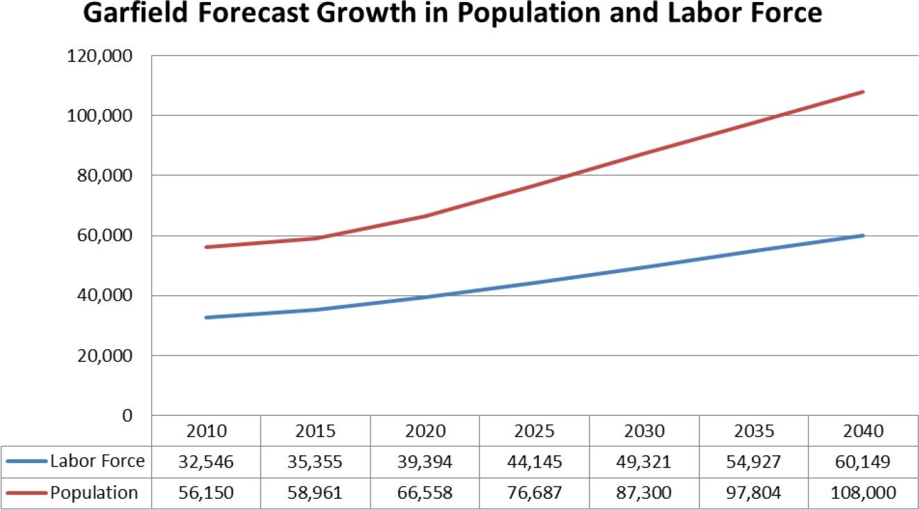

County Income

Steady growth (mainly due to oil and gas) in median household income took place until 2008, peaking at $42,294. In 2009 median household income for Garfield County decreased significantly. Moderate but steady growth has returned since 2011 with $57,022 reported for 2013 and $72,898 report for 2018.

Employment

Employment and the total number of jobs in the County was steady for much of the 2000’s, but the County’s employment outlook began to change in 2008 with a significant reduction in both jobs and the available labor force, and the unemployment rate spiked, reaching a peak of 11.7% in March 2010. Since then, the unemployment rate in the County dropped significantly and is currently (August 2019) at 2.4%, which is lower than the state and national average). Job growth has been steady since 2010 at approximately 1.1%.

Demographic Information and Relevance to the Fire District

As previously discussed for the County, a significant change in the District’s demographics was noted due to the economic downturn in 2008/2009. Since 2010, the District has seen a net decline in assessed valuation. This has been largely a result of a decline in natural gas prices and therefore drilling activity within the District. During the boom period, oil and gas activities had an assessed valuation of $2,169,993,540 and accounted for 95% of the property tax revenues. In 2021, total property tax revenues will decrease to $597,475,750 and oil and gas still represents 85% of revenues. The District has experienced a 71% decrease in assessed valuation.

Only because of the voter approved mill levy increase of 2.966 in November 2018 has the District been able to provide critical fire, ambulance, rescue and other emergency and non-emergency services as well as increase the Operational and Capital Reserve Funds. The mill levy increase only resulted in maintaining an operating revenue source similar to the 2011-2016 revenues. Reserve funds are important goals due to the unpredictable fluctuations in oil and gas activities, which drives revenue sources.

Community Input Summarize Past Comments

Summary Report - 1 January 2022

- Contact information
Responses undisclosed for privacy.







- Which option(s) best described your relationship? (Check all that apply)
120

100

80

60

40

20

0
Live in District Own a business Manage a business An employee None

Value | Percent | Count
I live in Grand Valley Fire Protection District | 90.48% | 19
I own a business in Grand Valley Fire Protection District | 14.29% | 3
I manage a business in Grand Valley Fire Protection District | 4.76% | 1
I am an employee of a business in Grand Valley Fire Protection District | 9.52% | 2
None of the above | 9.52% | 2
Total |  | 27

- If you own, manage, or are an employee of a business in Grand Valley Fire Protection District, what type of business is it?

Value | Percent | Count
Agriculture related business | 0% | 0
Energy related business | 0% | 0
Commercial business | 18.18% | 2
Other | 81.82% | 9
Total |  | 11

Responses "Other" | Count
Blank | 2
Non-Profit | 1
Education | 2
Legal | 1
Emergency Services | 1
Retired | 1
Family | 1
School | 1
Don’t own business | 1

- If you are a resident, what is your residency?

Value | Percent | Count
Full-time | 95.0% | 19
Part-time (months/year) | 0.0% | 0
Seasonal (what season) | 0.0% | 0
Vacation | 5.0% | 1
Total |  | 20

- How long do you intend to remain at your current residence?
Value | Percent | Count
less than 1 year | 0.0% | 0
1-5 years | 23.81% | 5
6-10 years | 19.05% | 4
More than 15 years | 57.14% | 12
Total |  | 21

- What is your age?

Value | Percent | Count
Less than 20 years old | 0.0% | 0
21-30 years old | 9.52% | 2
31-40 years old | 33.33% | 7
41-50 years old | 28.57% | 6
51-60 years old | 9.52% | 2
61-70 years old | 9.52% | 2
Over 70 years old | 9.52% | 2
Total |  | 21

- Gender

Value | Percent | Count
Male | 38.1% | 8
Female | 61.9% | 13
I prefer not to answer | 0.00% | 0
Total |  | 21

- What is the highest level of education you have completed?

Value | Percent | Count
High School/GED | 14.2% | 3
Tech School/Some College | 33.3% | 7
College Graduate | 33.3% | 7
Postgraduate Work | 19.5% | 4
Total |  | 21

- What is your average gross household income?

Value | Percent | Count
Less than $24,999 | 0% | 0
$25,000 -$49,999 | 0% | 0
$50,000-$74,999 | 38.1% | 8
$75,000-$99,999 | 42.86% | 9
$100,000 or more | 19.05% | 4
Total |  | 21

- How many people live in your household?

Value | Percent | Count
1 | 19.05% | 4
2 | 28.57% | 6
3 or more | 52.38% | 11
Total |  | 21

- How many household members are dependents?

Value | Percent | Count
0 | 38.1% | 8
1-3 | 42.86% | 9
3 or more | 19.05% | 4
Total |  | 21

- Have you ever used any of the following services? Check all that apply.

Value | Percent | Count
Fire Services | 47.62% | 10
Emergency Medical Services | 61.9% | 13
Fire Prevention Services | 28.57% | 6
Total |  | 21

- Have you ever used the local fire or emergency medical services?

Value | Percent | Count
Never | 28.57% | 6
Yes, within the past 6 months | 19.05% | 4
Yes, within the past 1 year | 9.52% | 2
Yes, within the past 5 years | 33.33% | 7
Yes, within the past 10 years | 4.76% | 1
Yes, within the past 25 years | 4.76% | 1
Total |  | 21

- In the last five years, how many times have you used the local fire or emergency medical services?

Value | Percent | Count
Never | 19.05% | 4
Yes, 1-2 calls | 71.43% | 15
Yes, 3-5 calls | 9.52% | 2
Yes, 6-10 calls | 0.0% | 0
Total |  | 21

- How would you rate the overall level of local fire-based emergency services?

Value | Percent | Count
Very Poor | 0.0% | 0
Poor | 0.00 | 0
Average | 4.76% | 1
Good | 19.05% | 4
Excellent | 71.43% | 15
No Opinion | 4.76% | 1
Total |  | 21

- How would you rate the overall level of local emergency medical services?

Value | Percent | Count
Very poor | 0.0% | 0
Poor | 0.0% | 0
Average | 0% | 0
Good | 19.05% | 4
Excellent | 66.67% | 14
No Opinion | 14.29% | 3
Total |  | 21

- Check all the services below that you believe should be provided by the Grand Valley Fire Protection District.

Value | Percent | Count
Fire Suppression (i.e. putting out fires) | 85.71% | 18
Fire code inspections | 85.71% | 18
Response to medical emergencies | 95.24% | 20
Fire investigations | 80.95% | 17
Response to hazardous materials emergencies | 76.19% | 16
Response to other perceived emergencies (e.g., carbon monoxide alarms) | 95.24% | 20
Response to motor vehicle rescues | 85.71% | 18
Technical rescues (e.g., water, ice, rope’s) | 71.43% | 15
Public education events and programs | 80.95% | 17
Community training (CPR, Basic First Aid, etc.) | 80.95% | 17
Total Respondents |  | 21

- Do you currently have a working smoke alarm in your home and/or business?

Value | Percent | Count
Yes, on all floors | 80.95% | 17
At least one | 19.05% | 4
Unsure | 0% | 0
No | 0.0% | 0
Total |  | 21
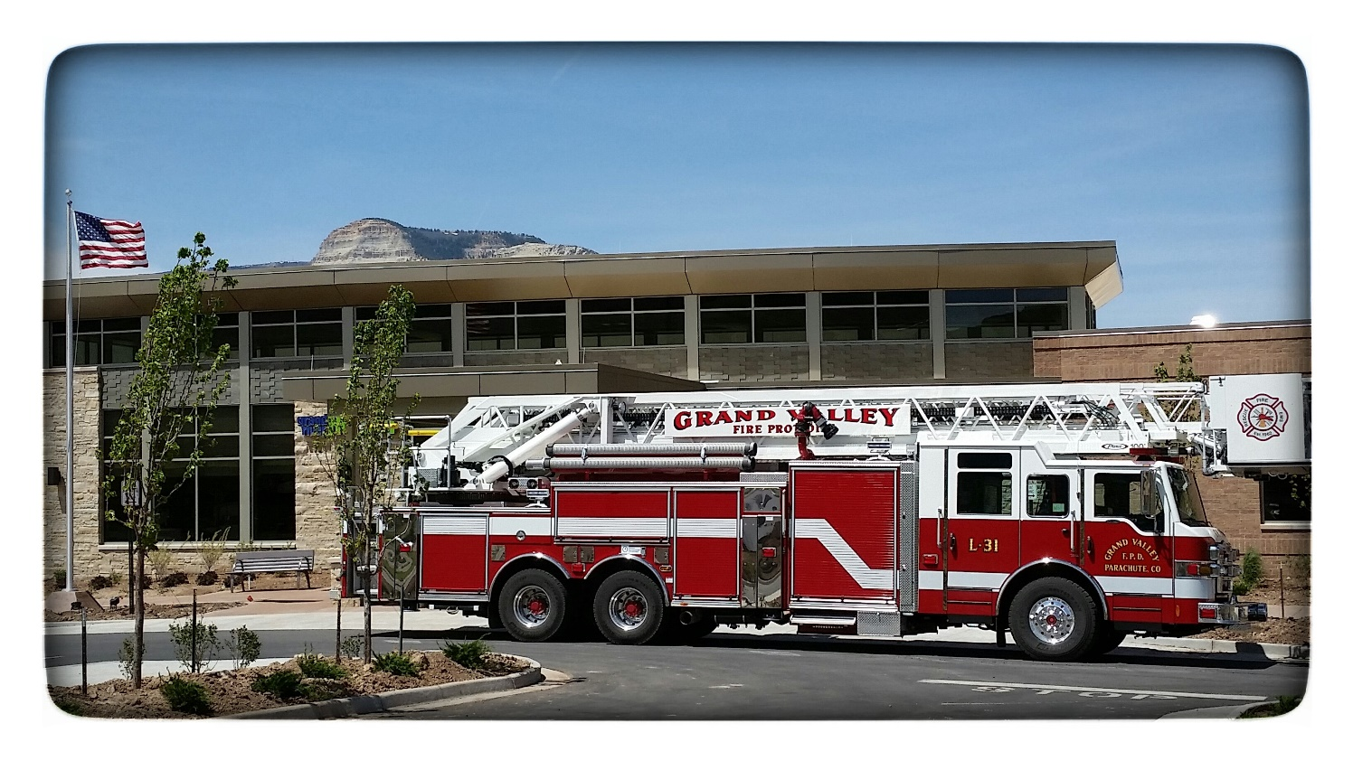

- Have you undertaken any of the following wildfire mitigation efforts on your property? Check all that apply.
120

100

80

60

40

20

0










Value | Percent | Count
Create defensible space around your home (thinning out 30 feet or to your property line, whichever comes first). | 47.6% | 10
Keep rain gutters clear of leaves and pine needles. | 71.4% | 15
Do not store combustibles on or under decks, including firewood. | 66.6% | 14
Rake up pine needles and leaves within 30 feet of any structure. | 42.8% | 9
Select plant species with fire resistant characteristics. | 23.8% | 5
Keep grasses mowed to a maximum height of 4 inches. | 90.5% | 19
Incorporate landscaping designs to break up fuel continuity (i.e., paths, rock walls, gravel, mulch). | 33.3% | 7
Keep addresses clearly marked and visible from both directions of traffic. | 66.7% | 14
Prune lower branches and remove dead or diseased trees and brush. | 61.9% | 13
Total Respondents |  | 21

- Please provide any concerns or comments related to local fire and emergency medical services.
- Great job that all you men and women do!
- Good job!
- This is an amazing fire station…very professional…kind…and quick to respond
- Thank you for your service
- We (residents of Battlement Mesa) need an evacuation plan.

Employee Survey Results

Summary Report - 2021 (update)

This survey is being completed by (optional):
Responses undisclosed for privacy. 21 surveys were completed.

- What is your involvement with the Grand Valley Fire Protection District?

Value | Percent | Count
Full-time employee | 42.9% | 9
Part-time employee | 42.9% | 9
Volunteer | 14.3% | 3
Other | 0% | 0
Total |  | 21

- Are you aware that the Grand Valley Fire Protection District has a Strategic Plan?
Value | Percent | Count
Yes | 95.2% | 20
No | 4.8% | 1
Total |  | 21

- If yes, how is it that you became familiar with the Strategic Plan?

Value | Percent | Count
Shift meeting | 25% | 5
Co-worker | 20% | 4
All staff meeting | 5% | 1
Supervisor | 30% | 6
Email | 5% | 1
Website | 15% | 3
Other, please specify | 0 | 0
Total |  | 21

*” Other” No responses were given for other.

- Grand Valley Fire Protection District's Strategic Plan identifies the following 4 issues. Please indicate the level of applicability each area has in relation to the services provided by the Fire Protection District (4 indicates least important).

 | 1 | 2 | 3 | 4 | Responses
Staffing Levels | 57% | 24% | 0 % | 19 % | 21
Response Time | 19 % | 33 % | 29% | 19 % | 21
Community Risk | 10 % | 24 % | 38 % | 29 % | 21
Communication | 14% | 19 % | 33 % | 33 % | 21

- Please indicate how strong a connection you feel there is between each goal and your company (Red, Green, Black or Admin) (4 indicates least important).

 | 1 | 2 | 3 | 4 | Responses
Staffing Levels | 52 % | 19 % | 14 % | 14 % | 21
Response Time | 14 % | 43 % | 19 % | 24 % | 21
Community Risk | 5 % | 14 % | 43 % | 38 % | 21
Communication | 29 % | 24 % | 24 % | 24 % | 21
- Please indicate how strong a connection you feel there is between each goal and your job (4 indicates least important).

 | 1 | 2 | 3 | 4 | Responses
Staffing Levels | 33 % | 19 % | 14 % | 33 % | 21
Response Time | 24 % | 29 % | 29 % | 19 % | 21
Community Risk | 5 % | 38 % | 33 % | 24 % | 21
Communication | 38 % | 14 % | 24 % | 24 % | 21

- In what ways have you been able to contribute to the Grand Valley Fire Protection District Strategic Plan?
- Closed loop communication, continuing education, emt provider for GVFPD.
- N/A
- Training
- This Survey
- Input to supervisor
- Helped write the document five years ago
- By trying to keep up on where the department is at with the strategic plan
- Community education
- I come to work on time, and I know my job
- I have operated as a part of the team in ensuring response time is prompt. I have assisted in picking up as many shifts possible to help with staffing. I ensure that I attend and participate in crew meetings where there is ample time to communicate.
- Picking up available shifts to help personnel out with their duties and actions within the public.
- I was a part of the original meeting.
- Gathering and collecting updated data and updating the new draft.
- Worked with the BOD, Chief staff, and line-level personnel from the start of the document.
- N/A
- Discussion with the crews
- This survey.
- Crew meetings with Admin staff
- Tasks that are assigned to me
- Just sharing my vision with my Captain to relay at meetings

- In what ways could you envision being able to contribute to, and participate in, the Grand Valley Fire Protection District Strategic Plan?
- Work full-time
- Being a part of meetings. Talking to the community.
- More shifts and more training
- More surveys
- Going to a meeting
- N/A
- By staying updated with changes
- Community involvement and community education opportunities.
- Continue to expand my job knowledge
- I could have more involvement in community risk reduction, such as assisting in community education events and community cooperation on wildland fire, health, safety.
- Gaining more experience through shifts and trainings to become a better asset to Grand Valley Fire Protection District.
- I am willing to represent the part time staff.
- Continue working with staff to complete the survey.
- Continue to work with the BOD's, Chief staff, and line-level personnel to update the document as needed.
- Give ideas and opinions
- Unsure other than talking with the crews
- Contributing on a committee level to envision true strategic goals that are specific, measurable, and obtainable.
- Being a member on the planning/ review committee
- By helping with the plan.
- Help strategize and plan in meetings.

- What do you believe are the top 3 strategic goals or issues that should be incorporated into the Grand Valley Fire Protection District Strategic Plan?
- Communication, staffing, and community risk
- Staffing, apparatus upkeep, maintaining good response times.
- N/A
- Recruitment/retention, budgeting, communication (internal/external)
- Apparatus Replacement Staffing Benefits and Pay
- Community and staff input. Community risk assessment reevaluated.
- Staffing, communication and being transparent, mental health SOG and employee evaluation of mental health
- Employee Health,
- Staffing, response times, training
- 1.Goal- Decrease response times by 20 percent in 2022 2. Goal- Construct and participate in at least 3 community risk reduction events /training with the community in 2022. 3. Goal- Increase employee participation in department meetings by 15 percent in 2022. I.e... more advertising of department meeting, aim to make crew meetings intentional versus routine.
- N/A
- Long term fiscal health of the District.
- 1. Enhance member training to better serve community 2. Improved prevention/inspection program 3. Maintaining fiscal responsibility and plan for declining oil & gas funding.
- FT staffing levels, Response times, Station #32 replacement
- Safety, mission, values
- Budget, staffing and community needs/happiness
- 1) Staffing - I believe working towards a fifth full time member per shift will bring consistency, crew cohesion, and operational efficiency. I believe with modest changes to the staffing plan this can be achieved with minimal cost to the organization. There are also potential grants in which can help ease the initial cost of the firefighter (SAFER Grant). 2) GVFPD is currently the only agency in Garfield county that does not operate with some sort of mobile command apparatus for incident command and safety. I believe moving toward making this a part of our response plan would be a huge strategic goal. Staffing being the key element to making that a success. 3. Continuing to embrace technology and allow it to further improve and facilitate our communications and safety.
- Update policies/ procedures, Staffing levels, and wildland deployment
- Staffing safety community

- What key elements do you think are missing from the Grand Valley Fire Protection District Strategic Plan?
- Lack of staffing at times
- N/A
- I do not think it is missing anything
- Attainable goals
- None
- Updating these questions!
- An actual apparatus replacement program that is obtainable
- Staffing
- Staffing
- The key element I see missing is advertisement/celebration of small wins within the current strategic plan. The wins are there but is everyone aware?
- N/A
- A strong emphasis on fire apparatus and training.
- None
- Current elements appear appropriate.
- None
- Unsure
- I would like to see the strategic goals be more progressive, specific, and tangible for growing the operational efficiency of the organization with community need and fiscal responsibility in mind
- Current/ updated clear and consistent policies/ procedures. Wildland deployment model/ goals
- Staffing safety
- Unknown
- Your opinion matters! Please provide any additional thoughts regarding the Grand Valley Fire Protection District Strategic Plan.

- N/A
- N/A
- No additional thoughts
- GVFPD is a great place to work!
- N/A
- Don't lose focus on the plan and keep moving forward. In the big picture I feel GVFPD is doing a great job at budgeting and keeping members updated on changes within in the system.
- More emphasis on employee health and physical fitness
- None
- I don’t have an opinion to offer, but I am motivated to play a part in accomplishing the districts strategic goals especially if it includes being pushed outside of my knowledge/comfort zone.
- I do not have enough information for an opinion towards the Strategic Plan.
- The District has been a great place to work, and I feel the Board and Management sincerely care about the residents and employees of the District.
- We do a great job providing services to this community.
- Nothing additional to add.
- Thanks
- I’m excited to be able to give feedback on this document. With the finished product I am hoping the vision for our future is clear for all members so that we can all work towards a common goal/ objective outside of the “status quo”
- In addition to the question 9 & 10, I feel the district really needs to plan for a new Station 32. I feel the district has outgrown the current station.
- None
- No additional comments

Past Strategic Plans

Strategic Planning for the Grand Valley Fire District

In September of 2011, a plan was initiated as the “Proposed Roadmap for the Grand Valley Fire District” as well as to dialogue on the topics of Community Risk, Response Times, and Staffing Levels.

In 2016 a comprehensive Strategic Planning effort was undertaken with a third-party consultant, which resulted in an update of District goals and strategies, with community, staff, and Board input.

In past strategic planning sessions areas that were working well were identified:

What Is Working?

Staffing Levels

Crew Dynamics

Quality of Service

Response to community

Up to Date Training

Good feedback

Good reputation

Good support from Board: active and involved

Financially Solid

Positive Feedback

Communication is good

Efficient administrative processes and support

Diverse board background of knowledge and experience

CQI/CQA – medical reports

Dedicated Workforce

Areas needing work were identified.

What Needs Work?

Communication

This item had also been identified as something that was working well. It is important to note that communication had taken a major leap forward. A variety of communication methods are being utilized within the organization to convey information: hard copy memorandums, email, and text messaging. Review that had been conducted had helped identify areas for improvement; many of which they were currently working upon.

The communication process needed to be better defined and then supported by all to ensure that all levels of personnel had an identified point of contact. Information is delivered consistently to and through that point of contact and the point of contact is to work to resolve conflict within their respective group through the conveyance of timely and accurate information.

Morale

The fluctuation in morale was related to gaps in communication and the continuance of rumors.

Benchmarking

Do a better of job of benchmarking progress in areas identified as areas of concern.

OPERATING STAFFING LEVELS

We believe the operating staffing levels in total are correct. Need to do a better job of allocating personnel across the calendar to assure adequate coverage.

WHO

4 (paid staff)

2 + (Members) Depending on calendar.

WHAT

4 (paid staff) Backfill any vacancies with the primary 12 then put vacant spot out to part timers.

In order to backfill open positions.

1. Need minimum certifications

2. Need to put in x amount of hours in a certain time frame.

WHEN

As soon as parameters are defined.

HOW

Identify appropriate group to determine parameters and then make recommendations to the Chief/ Board of Directors.

WHERE

Station 31. Evaluate as needs change.

WHY

Protect District lives and property in a safe, effective and consistent manner.

WHO

RESPONSE TIMES

All members of the Grand Valley Fire Protection District responding to emergencies.

WHAT

To assess the effectiveness of the policy and the actual response times that we currently have, and to try to improve these.

WHEN

Some items may be effective now. Some may be better later when we build a new lower station so that there are no issues with male/female/part-time/full-time or sleeping facilities. Wintertime issues cause us to have a hard time getting vehicles down the hill when the roads are icy. We have additional response time issues during these wintertime icy conditions and during high MVC responses on I-70 in winter.

HOW

Add personnel to the lower station to shorten response times to Parachute proper. Research showed that approximately 45% of the calls were in this area. This may mean that we add personnel to accomplish this, or we may be able to utilize existing personnel on a trial basis. Green crew has offered to be guinea pigs to try the arrangement for three months to assess the feasibility.

It may or may not be counterproductive at this time splitting the crew and the effect on morale. The benefit of having additional personnel at the Parachute station would be an advantage to the Parachute response times; there is a benefit to having personnel on scene 3-4 minutes quicker. One solution would be to put some funds into remodeling the lower station to make it more usable. Nicer facilities may ease any morale issue.

Possibly utilize the seasonal personnel in a rotation basis, during the months they are here.

Additional drills with oil field personnel to ensure that the people who impact the response will be in place to assist with getting our personnel to the scene in a timelier manner.

WHERE

Responses within the district boundaries of the Grand Valley Protection District.

WHY

To provide a standard for emergency response time when dispatched on emergency incidents, assess how we are doing on a consistent basis and improve if possible. We do have an SOG on this topic.

III. Standard

The standard turnout time for call for service between 0800 hrs. and 2200 hrs. shall be 120 seconds or less.

The standard time turnout time for calls for service between 2201 hrs. and 0759 shall be 180 seconds or less.

Do not delay preparation for response at the start of your shift. Get your gear ready as soon as you arrive at your assignment.

Do not rely on others to take care of your gear.

Do not continue to talk during dispatch. Listen carefully.

When dispatched, stop what you are doing and hustle to the truck.

When showering, doing physical training, or sleeping, always have clothes close at hand and ready to go.

During physical training, avoid getting too far from your apparatus. Physical training is not an excuse for a delayed response.

Always be ready to respond it’s what we do.

COMMUNITY RISK

WHO

The Board of Directors

WHAT

Define type of response, level of responses, and capabilities of responses per call loads

WHEN

Before the calls happen. Everybody needs to know what is expected of them from the community. This can change based on facts and changing community.

HOW

Call load vs. staffing, risk vs. benefit, evaluate standard and competency (qualified volunteer)

WHERE

At the board level with staff input.

WHY

Find out community expectations, fund, staff and train to meet those expectations.

COMMUNICATION

WHO

All members of Grand Valley Fire Protection District

WHAT

Improving communications

WHEN

Daily

Monthly

As needed

HOW

Follow chain of command

Morning staff briefings-with agendas

Monthly newsletter-all senior staff, admin staff and board members will have input

WHERE

Ops room

US Mail-new letter

Email

WHY

Continuous, clear, concise communication

This section will be updated following meetings with staff and suggested action items:

Actions Items and Associated Deadlines

Following the presentation of each group, action items, deadlines for completion, and leads were identified.

Staffing Levels

Action:

A cost benefit analysis to adding a 5th fulltime employee to all three crews including the impact it will have on the current staffing levels.

Deadline: January 1, 2023

Lead: Deputy Chief Jackson & Captain Oldright

Mental Health and Safety

Actions:

Prepare recommendations on how to communicate to the members of the District a list of resources for mental health for the members and their families.

Deadline: June 2022

Lead: Kim Reeves, Training Chief Duprey & Firefighter Jed Johnston

Communication

Actions:

A list of suggestions from all levels, admin, fulltime, part time and volunteers on how to communicate better and be more transparent.

Deadline: June 2022

Lead: Captain Spaid

Station 32

Actions:

A proposal on upgrading or building a new station with a cost benefit analysis and how it would change or impact the community.

Deadline: January 1, 2023

Lead: LT Blair

Wildland Deployments

Actions:

A detailed plan of deployments for each of the next 5 years on what the deployment model will look like and how each one of these will impact the current staffing levels with covering shifts.

Deadline: June 2022

Lead: Chief Blair & Deputy Chief Jackson

