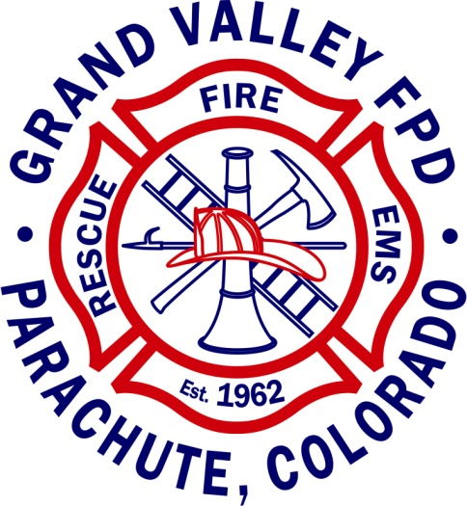
Public Notice

Grand Valley Fire Protection District Board Vacancy:

The Grand Valley Fire Protection District has a vacancy on their Board of Directors. The term of said vacancy would be for the 4-year term 05/2023 to 05/2027, with re-election required at the next scheduled election 05/2025. Board meetings are held once per month, at 9:00 am, the third Wednesday January through October, the second Wednesday in November and the first Wednesday in December. Pension Board Meetings are prior to the Regular Board Meeting at 8:30 am, in February, May, August and November. All meetings are at the Battlement Mesa Fire Station. Please submit a letter of interest by April 7, 2023.

Letters can be mailed or emailed to:
Grand Valley Fire Protection District
124 Stone Quarry, Parachute, CO 81635
admin@gvfpd.org

If more information is needed, please call 970-285-9119.

