GRAND VALLEY FIRE PROTECTION DISTRICT

0124 STONE QUARRY RD
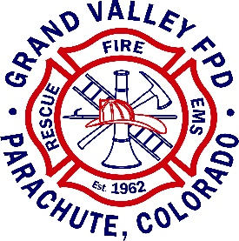
PARACHUTE, CO 81635
PHONE: 285-9119, FAX (970) 285-9748

Lateral / Part-Time Firefighter

The Grand Valley Fire Protection District is developing an eligibility pool of qualified applicants to fill current positions with the Fire District.

Duties to include:

Performs firefighter and rescue operations for the combating, extinguishing and prevention of fires as well as for saving life and property. Performs duties and responsibilities pertaining to vehicle rescue and extrication, hazardous materials response, and mitigation. Also, performs emergency medical duties which include the care and transport of medical and trauma patients.

Minimum Qualifications: Applicant must have all qualifications to apply.

Current Colorado State EMT-BIV or Paramedic.

NWCG Wildland Firefighter II or higher.

Current Colorado Structure Firefighter I with Hazmat Ops or higher.

Compensation:

EMT-IV / Firefighter : $20.69 – $28.64

AEMT-IV / Firefighter : $22.39 – $30.35

Paramedic / Firefighter : $24.09 - $31.97

Pay commensurate depending on experience.

The Application process:

Qualified applicants should submit a letter of interest, application, resume, three recommendation letters and copies of current certifications to the Deputy Fire Chief no later than 17:00 on February 23rd, 2024. The interviews will be conducted on March 6th, 2024.

Application is available at www.gvfpd.org or upon request at

Station 31, 0124 Stone Quarry Rd. Parachute, CO. 81635

Submit applications to: anduprey@gvfpd.org

